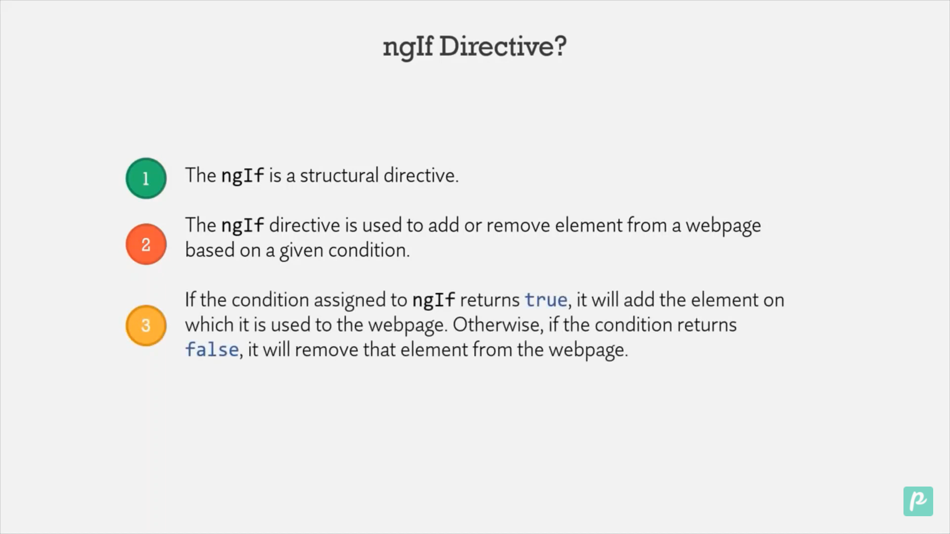

We are using it for displaying the content

  <input type="text" (input)="changeInputValue($event)" />

  <span \*ngIf="searchValue != ''">You search for "{{ searchValue }}"</span>

If searchValue is not null then content will be displayed

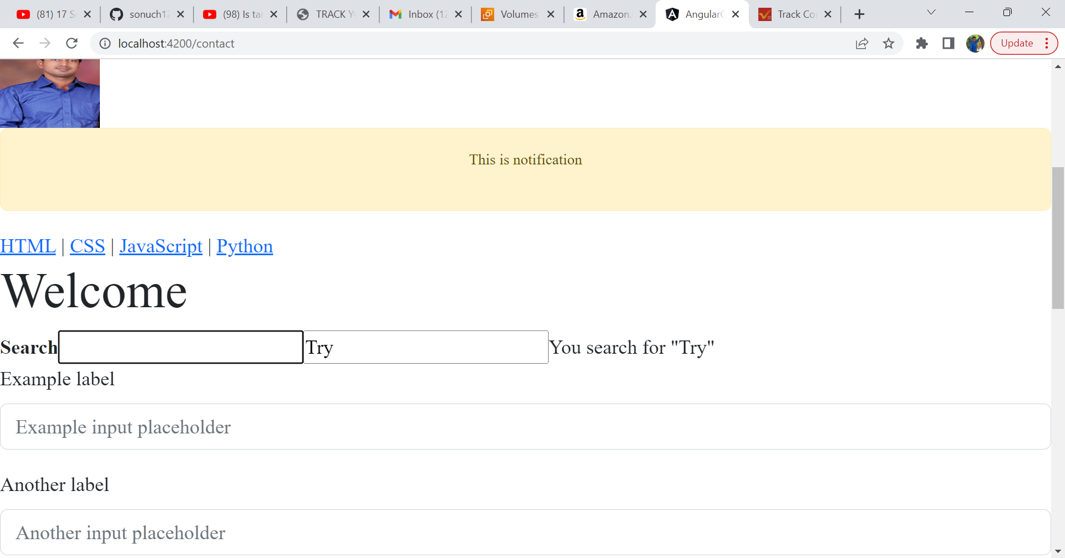

As we start typing the things it will show the content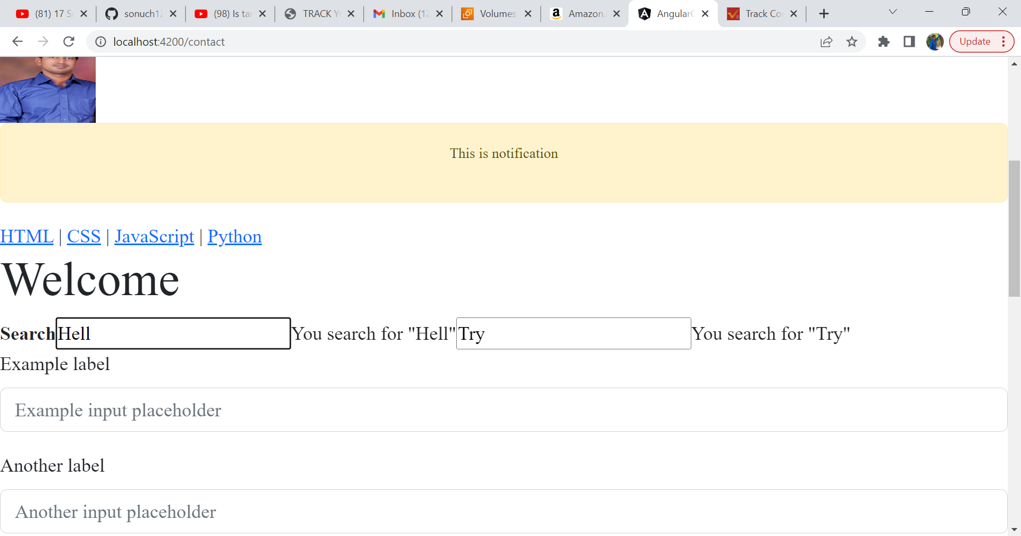

We are showing button if product is available

  <br />

  <button class="btn btn-success" \*ngIf="p.details === 'availabe'">Buy</button>

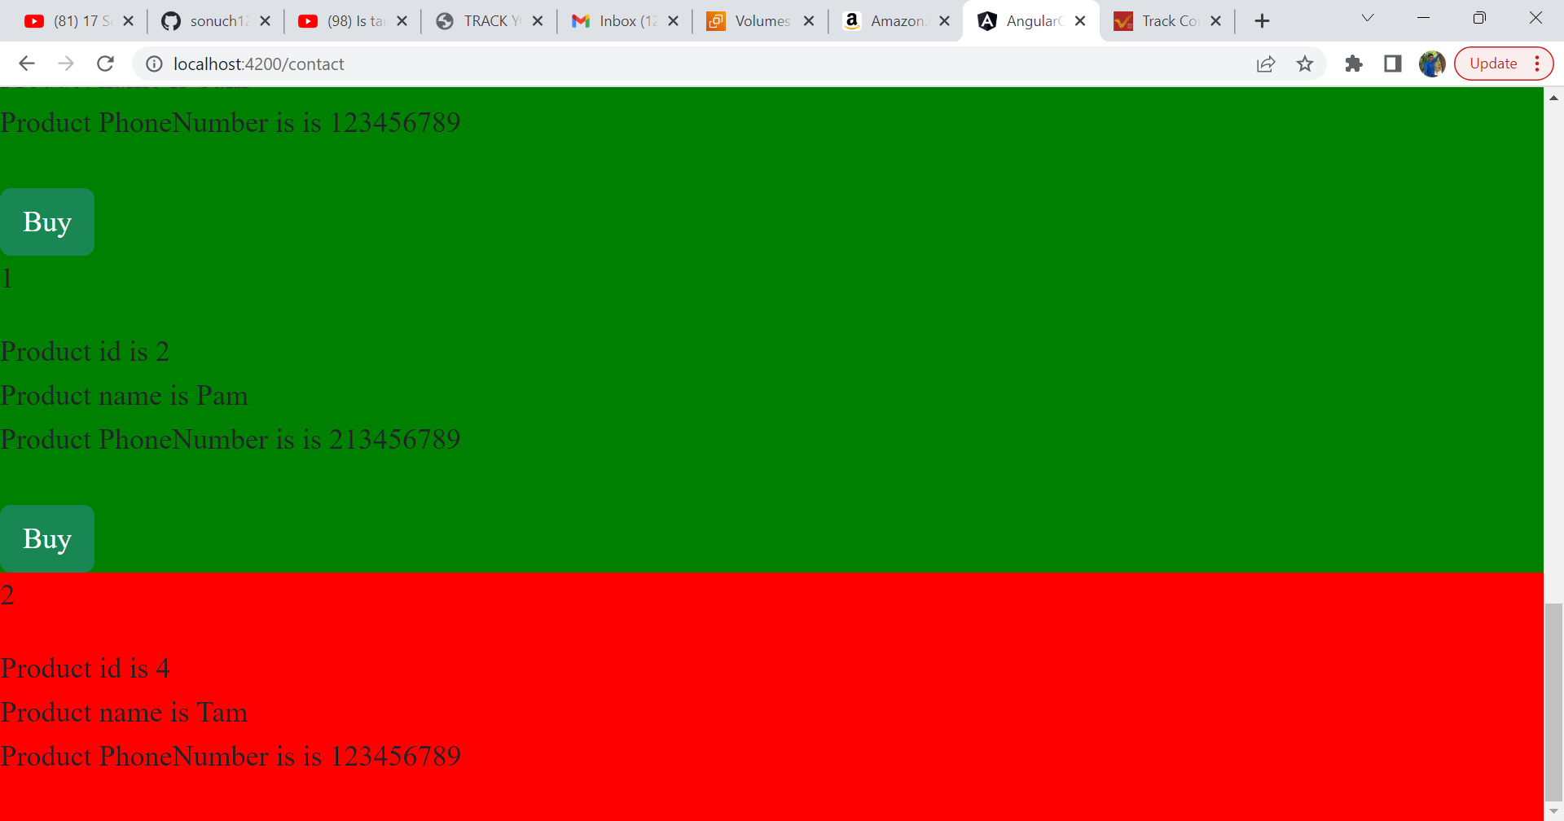

Case 3 : When we want to show notify button .

Use ng-template and give name to template using #name

 <button class="btn btn-success" \*ngIf="p.details === 'availabe'; else notify">

    Buy

  </button>

  <ng-template #notify>(nameof button is notify)

    <button class="btn btn-warning">Notify</button></ng-template

